Download the tableau desktop 14 free trials.

<https://www.tableau.com/products/trial/desktop>

A post said that you can download another old version to extend this 14 day trails but I am not sure.

Verson release of Tablea:

https://www.tableau.com/support/releases

Download the Azure SQL database connector and installed it as the instructions below.

<https://www.tableau.com/support/drivers?edition=>

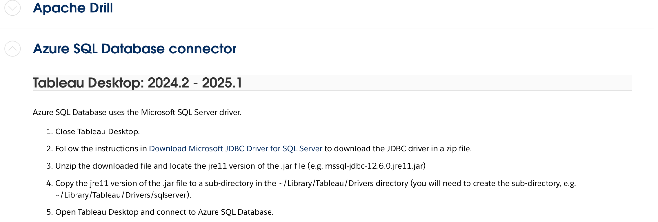

Choose Azure SQL Database

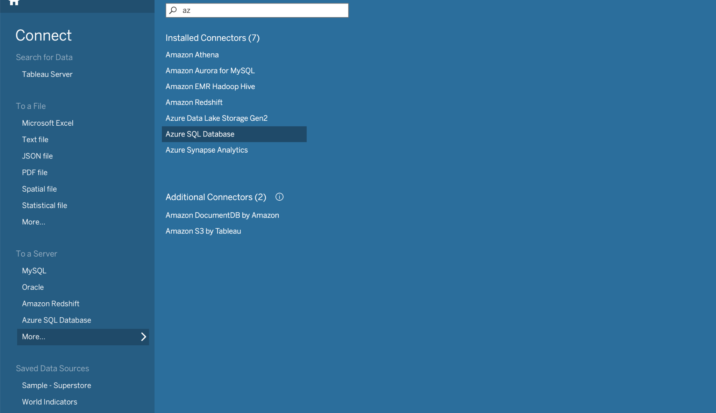

Then sign in

